SYSTEM ARCHITECTURE
Weather-Based Crop Advisory System | System Architecture Document | Version 1.0

1. Introduction
This document describes the proposed logical architecture of the Weather-Based Crop Advisory System. It explains the main modules, their responsibilities, the flow of weather information, and how crop-specific advisory messages are produced.

1.1 Purpose
The purpose is to provide a technical view of how the farmer interface, backend application, database, weather service, and rule-based advisory engine work together.

1.2 Scope
The system supports farmer registration and login, selection of farming location and crop, retrieval of weather information, rule-based advisory generation, and administration of crop information and advisory rules. It is a decision-support system and does not guarantee crop outcomes.

2. Architecture Overview
The system follows a layered web application architecture. Users interact with the frontend. The backend validates requests and coordinates data access, weather retrieval, and advisory generation. The database stores application information, while an external weather provider supplies weather data.
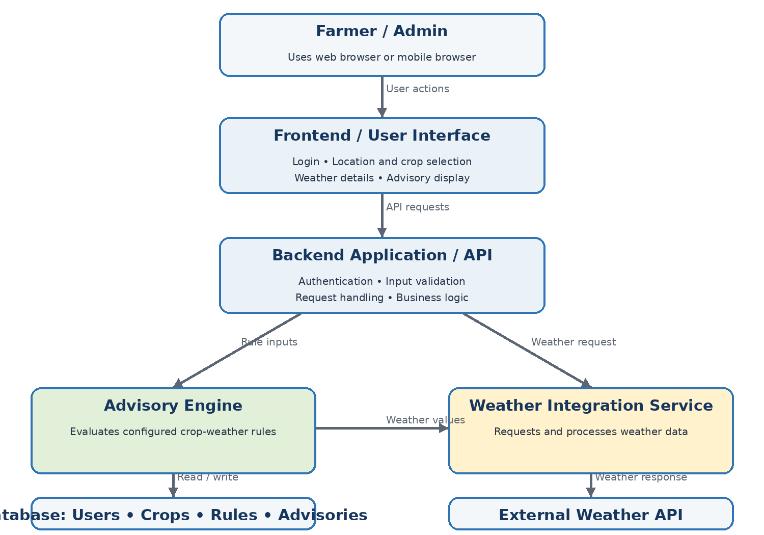
Figure 1. High-level logical architecture

3. Architectural Layers and Components
Component | Responsibility
Presentation Layer | Displays login, registration, crop and location selection, weather details, advisory results, and admin screens.
Backend / Application Layer | Receives requests, validates inputs, applies access control, coordinates services, and returns responses.
Weather Integration Service | Requests weather information, processes provider responses, and handles missing or invalid data.
Advisory Engine | Evaluates weather values against configured rules and prepares relevant suggestions for the selected crop.
Data Layer | Stores user details, crop information, advisory rules, and advisory history where required.

3.1 Farmer Module
Allows a farmer to register or log in, select a farming location and crop, view weather information, and read the generated advisory. The interface should clearly show when weather data is unavailable.

3.2 Admin Module
Allows authorized administrators to maintain crop information and configure advisory rules. Administrative functions must be restricted to authorized users.

3.3 Weather Integration Module
Sends a request to the selected external weather provider using location details. It processes available values such as temperature, rainfall or rain probability, humidity, and wind. Exact fields depend on the selected provider.

3.4 Rule-Based Advisory Engine
Compares available weather values with configured rules. When a condition is satisfied, the system prepares a corresponding suggestion. Rules should be configurable where practical.

4. Main Data Flow
Step | Description
1. User input | Farmer logs in and selects a location and crop.
2. Validation | Backend checks the user session and validates selected inputs.
3. Weather retrieval | Weather service requests current or forecast data from the external provider.
4. Data handling | Backend checks whether the response is valid and contains required values.
5. Rule evaluation | Advisory engine compares weather values with rules applicable to the selected crop.
6. Advisory response | System returns suggestions or a clear data-unavailable message.
7. Display | Frontend displays weather details and advisory messages.

5. Data Architecture
The logical data model may include the following entities. The final database schema should match the implemented application and its ER diagram.
Entity | Purpose / example information
User | User ID, name, login/contact details, and role.
Crop | Crop ID, crop name, and crop-related information.
Location | Location ID, place name, and coordinates where required.
WeatherData | Location, observation/forecast time, temperature, rainfall, humidity, wind, and provider status.
AdvisoryRule | Rule ID, applicable crop/category, condition, advice text, and active status.
Advisory | Generated advice, date/time, user/crop/location reference, and related rule or weather data.

6. External Interfaces and Dependencies
The main external dependency is the weather data provider. The backend communicates with it through its documented API. The application must handle network errors, invalid responses, rate limits, missing fields, and provider downtime. API credentials, if required, must be stored securely on the server side and must not be exposed in frontend code.

7. Security Architecture
The system should authenticate users before allowing access to protected features and apply role-based authorization for administrative functions. Inputs must be validated on the backend. Sensitive configuration values should be kept outside public source code. Communication with external services should use secure transport where supported.

8. Error Handling and Reliability
If weather data cannot be retrieved or is incomplete, the system should not generate weather-based advice from missing values. It should display a clear message that weather information is unavailable and allow the user to retry later. Errors should be logged without exposing secrets or sensitive details.

9. Design Considerations
Consideration | Approach
Maintainability | Keep weather integration, rule evaluation, and user interface responsibilities separated.
Scalability | Keep modules loosely coupled so that more crops, rules, or weather providers can be added.
Usability | Use clear labels and simple advisory messages suitable for non-technical users.
Availability | Handle external API failure gracefully and communicate data status.
Correctness | Use valid weather values and applicable rules when generating advice.

10. Technology Stack
The exact technologies must be filled in according to the tools actually used in the project. The system logically requires a frontend framework, backend/API technology, database, external weather API, and rule-based advisory logic. Do not list a technology as implemented unless it is present in the working project.
Area | Implementation detail
Frontend | Confirm from the implemented project
Backend / API | Confirm from the implemented project
Database | Confirm from the implemented project
Weather API | Record actual provider name and API version
Hosting / Deployment | Record after deployment; may remain pending during local testing

11. Conclusion
The proposed architecture separates the user interface, backend processing, weather integration, advisory rules, and data storage. This makes the system easier to understand, test, maintain, and extend. The reliability of advice depends on valid weather information and correctly configured rules.
Note: This is a logical architecture document based on the project scope. Update implementation-specific details after checking the final source code.

